American Video Game Company
Software Project
Customer Relationship Management System
Elisa Marchione
[Date]
[Version x.x]

Introduction
American Video Game Company (AVGC) needs a software solution for a customer relationship management system (CRM). My proposal is to utilize an existing off-the-shelf system instead of building a custom software solution. AVGC can build a system with Salesforce, the cloud-based Software as a Service (SaaS) CRM. By doing so, they will be able to take advantage of all the existing infrastructure and functionality that Salesforce has already built to help hundreds of other companies manage their customer data and business processes – things like security, integrations, scalability, reliability, and reporting.

A.1. PUrpose Statement
The purpose of a new system is to provide American Video Game Company with a unified, reliable, scalable platform to effectively manage their customer data and business processes

A.2. Overview of THE PROBLEM
American Video Game Company’s needs to bring together multiple disparate business processes and data sources into a single system. Their current system is not scalable and that has become evident with the recent growth they’ve experienced. Their workflows are manual and kept separate from one another. There is not a single source of truth for their data. They cannot sustain more growth without a unified system.

A.3. Goals and Objectives
The goal of the project and proposed solution would be to utilize Salesforce’s excellent features for customer relationship management and process improvement. It would be a secure, reliable, legal way to store and manage this data. The system would allow the company to bring together all its existing data sources into one unified database. AVGC could keep track of its contacts, businesses, quotes, orders, opportunities and much more. Sales tracking and management would be more streamlined and effective with the use of Salesforce’s robust reporting system.

A.4. Prerequisites

Number | Prerequisite | Description | Completion Date
1 | Current data storage | Get a list of all current data storage locations. Make sure we have access to all current spreadsheets.
2 | Current business processes | Get a list of current processes that need to be converted.
3 | Current number of users | Get an accurate number of internal users that will need licenses.

A.5. Scope
The proposed solution of utilizing Salesforce Sales Cloud will include the following:
- Users will have appropriate access to the system during business hours. These settings can be configured appropriately.
- A customer database for all existing contact types will be built.
- All existing data sources will be migrated into the new system.
- Sales processes will be converted into objects, fields and automations within the system.
- Users will be able to log and manage customer activities within the system. They will also get setup with an Outlook integration to properly record all email interactions.
- Base reports will be built, and user training on the reporting system will be done to ensure self-service.
The proposed solution will not include the following:
- While Salesforce does have a mobile application, the proposed solution will be focused on access from desktop computers and laptops.

A.6. Environment
One of the key benefits of using Salesforce is that it resides in the Cloud. As they describe it themselves, cloud computing is a “…kind of outsourcing of software, data storage and processing. […] Information and programs are hosted by outside parties and reside on a global network of secure data centers…” (**** How do I attribute?) Because of this, the need for specific hardware is greatly reduced. Users will need web-enabled computers or laptops and reliable internet access.
Application security is also handled by using Salesforce’s existing infrastructure of login policies and multi-factor authentication.

Requirements
American Video Game Company is looking for a solution to bring together their various business data and processes into a unified system. They want a good user experience that’s configurable and adaptable. Below are some of the specific requirements and how they will be handled by the proposed solution of using Salesforce.

Business Requirements
AVGC is looking for a flexible, configurable, scalable customer relationship management (CRM) system to store and access all customer information.
Salesforce is a proven CRM solution. By default, it offers a baseline of standard objects in the database, such as Accounts, Contacts and Opportunities, that can be easily configured using custom fields. Further configuration can be done by creating custom objects in the database to really fine-tune the data that can be entered as part of the business processes.
Salesforce uses user profiles to manage permissions and security. Profiles can be configured with read/write access to objects and fields. They also determine the page layouts that are seen for each object, and the different workflows and automations that occur. (REFERENCE Security Guide)

User Requirements
Users from different departments and locations need to all be able to access the same data in real-time. There needs to be a single source-of-truth for all employees of the company, for transparency purposes, and so appropriate business decisions can be made.
Salesforce provides a database as a single source-of-truth. Any employee can access the information in real-time and feel confident that it is up-to-date and accurate. By bringing together all disparate company processes into a centralized location, different departments can get a full picture of a customer’s interactions, history and information. Salesforce describes this idea as “connecting your business silos”, and confirms that “a shared platform and process for managing customer relationships across functions can really help” (REFERENCE)

Functional Requirements
American Video Game Company has asked for a way to report on all data within the system. They need to have standard reports already built, as well as a way for users to build custom reports on an as-needed basis. This also includes the need for dashboards made up of different reports. Salesforce has a robust reporting system that will exceed the requirements that they’re asking for. The system comes with default reports based on the standard objects that are commonly used for business purposes. It also allows for the building of custom reports on any combination of the standard and custom objects. Users can easily query the data and build a report. Features such as grouping, cross-filters, and aggregation allow for more advanced queries and understanding of the data. Dashboards are a nice way to bring together multiple reports into one place and get a quick visual on a lot of data. With sufficient training, any user can build reports as needed. (REFERENCE)
Another functional requirement is that of activity management. AVGC would like to be able to log all activities and interactions between employees and customers as part of their database. Salesforce offers built-in functionality of logging activities – tasks, calls, emails, and events – to various objects in the database. Users can use integrations, such as an Outlook integration, to help automatically log emails sent and received by customers. By using this feature of Salesforce, the company can easily see a chronological history of interactions with every customer and contact. The activities are tied to specific users in the system, so there is always an audit trail. By utilizing this feature, Salesforce will become a centralized place to find a record of all dealings with customers.

NonFunctional Requirements
A nonfunctional requirement is that of performance optimization. AVGC needs to allow all its 2000 users to be able to access the system. This includes the ability for up to 500 users to be able to access the system concurrently, at peak times.
Salesforce is a cloud-based CRM, which means that it allows users to work from anywhere, and everyone can have access at the same time. (REFERENCE) Users will be granted user licenses to be able to access the system. Depending on login policies set within Salesforce, users will have access to the system when appropriate.

SOFTWARE DEVELOPMENT METHODOLOGY
The company has selected the waterfall software development methodology for this project. This methodology follows a predictable pattern of planning and action. The project goes through specific steps in order. Each new phase of a project is started only after the previous phase has been completed.

Advantages of the waterfall method
There are plenty of advantages to the waterfall methodology when specific criteria are met. A waterfall approach can be very beneficial for a large project that requires a lot of planning. The bulk of the planning is done up-front and then the project is built after that. When the steps are done in a predictable manner, timelines and costs can be more easily calculated. In the case of the system for AVGC, the project is very large since it is changing the underlying infrastructure of the entire company. It requires a lot of planning to make the change.
Waterfall projects work very well when the requirements are known beforehand. The idea that the project is going through specific steps means that there will not be a lot of iteration or change happening. The requirements will be determined, then the project will be planned out, and then it will be implemented. In the case of AVGC’s project, the requirements are known in advance. They would like to build out a system that replicates their current business processes as closely as possible. They do not want to change the processes unless necessary, so we can expect to rely on those requirements for the most part.
Waterfall projects are easier to estimate costs and timelines because requirements shouldn’t be changing. We can make reasonable assumptions about how long each stage of the project will take. For AVGC, we would make a plan with every department’s business processes that need to be replicated and determine estimates for how long it would take to build in Salesforce.
The waterfall approach makes it easy to find bugs early, and the lack of constant changing requirements means that new bugs will be less likely to develop in the future. The fact that we’re using an out-of-the-box solution will also help with this, as Salesforce’s system is very reliable and tested.

disAdvantages of the waterfall method
The possible disadvantages of the waterfall method stem from its lack of flexibility for changes. Once the project has moved forward into a new stage, it does not go back into a previous stage. If something does need to change, this can really throw a wrench into all the planning that was originally done. American Video Game Company has specified in their requirements that they want to avoid changing current business processes as much as possible. However, it’s a possible risk that seeing the benefits of Salesforce could make the stakeholders change their mind. They could start to think of new and improved ways that they could do their business processes once they see the benefits of having a unified CRM like Salesforce. The power of automation and the ability to quickly make changes and improvements could get their wheels spinning, leading to requests for changes to the requirements. Using the waterfall methodology would mean that we would be less able to handle changing requirements.
Another disadvantage is the overall amount of time it can take to release a waterfall project. Because there is so much planning at the beginning, and because each step needs to be completed before moving on, it can be a long time before there is anything ready for users to use. We will spend a lot of time in the planning stage for this project because it is such a big undertaking to convert all business processes into a unified CRM. We will be bringing together all departments into one system, and there isn’t an easy way to do this gradually. Users might feel like they are waiting a long time for the new system to be ready.

Advantages of SCRUM
A different project methodology that could be taken is that of Scrum. Scrum is an iterative process that starts out with the minimum viable version of a project and iterates on this for many cycles to add more and more functionality and optimization.
Scrum would be able to handle changing requirements much more smoothly because planning happens as part of each development cycle (generally every few weeks). If the requirements have changed in the meantime, they can be accommodated and updated. If the stakeholders for the AVGC project were to start seeing the benefits of using Salesforce to improve their current business processes, these changes could be handled more easily with Scrum.
With a Scrum approach to the project, the minimum viable product could be a contact management system and nothing else. With each sprint, more and more functionality could be added. Each department’s processes could be planned for and built within a certain number of sprints.
Another feature of Scrum is that of sprint planning and sprint reviews, which would mean that the development process is constantly being reviewed and updated based on how things are going. This can be helpful for development teams to consistently improve their own processes.

disAdvantages of SCRUM
There are some possible disadvantages of Scrum. There is a greater possibility of bugs and need for refactoring since requirements are potentially always changing. A lack of full planning up front can lead to more disparate code structure that might need to be changed periodically with different iterations. With the project for AVGC, it would be helpful to have a more global picture of all the different business processes coming together to more effectively plan out the database structures.
Using Scrum can often lead to a lack of documentation. This is because the requirements are constantly changing, and sprint cycles do not always leave enough time to properly document. This could be disadvantageous for American Video Game Company and their efforts to bring all their current business processes into Salesforce. A lack of documentation could impact the users’ ability to be properly trained, and potentially negatively impact user buy-in because of that.
Scrum also has the possible disadvantage of negatively impacting stability. If the requirements are not clearly determined initially and/or are constantly changing, it could lead to a loss of an overall vision of the project. AVGC’s project has a lot of clear vision and requirements from the get-go. It’s clear what needs to be done and straying from this could lead to a more disjointed system.

best SUITED
In our case, the waterfall methodology does appear to be the best suited for accomplishing the goals that American Video Game Company has. There are clear requirements that exist, and their hope is to not have a lot of change. The business requirements are to avoid changing existing processes unless really necessary. The design can be done up front and it can be determined how best to use Salesforce to accomplish the needs of the project.
It is a large project that involves a lot of planning. While it could be done iteratively, it seems best to bring everything together into one system. Especially if current processes are disjointed and separate, we want those departments to be able to work together in one system.
There will be a lot of big design up front and there will be a learning curve with getting everyone trained and using the new system; this can be done with proper planning, training and documentation. This is much easier to accomplish if we do have the planning done at the beginning, and if the requirements are not constantly changing. It will be easier to get everyone trained accordingly if we have a single source-of-truth with proper documentation of the system and processes.
A detailed design will make it easier to go through development without the worry that requirements will change after-the-fact. Development work can be done after all the planning has been done. This also leads to be a more predictable timeline and cost estimate for the project as a whole.

Design
Salesforce will allow for American Video Game Company to keep better track of their communications with customers, as well as bring together all their disparate business processes into one unified system.

UML DIAGRAM – Activity management
Salesforce provides standard objects for activity management as part of its core features. In this project, we will utilize the existing data structures provided by Salesforce to keep track of businesses, contacts and the interactions between them and the company’s employees.
Contacts will be assigned to businesses. Any type of activity done with a contact or business, such as phone calls, email, tasks and events, can be tied directly to those objects. The information on Activities will help provide a historical perspective on all the different communication that has happened.

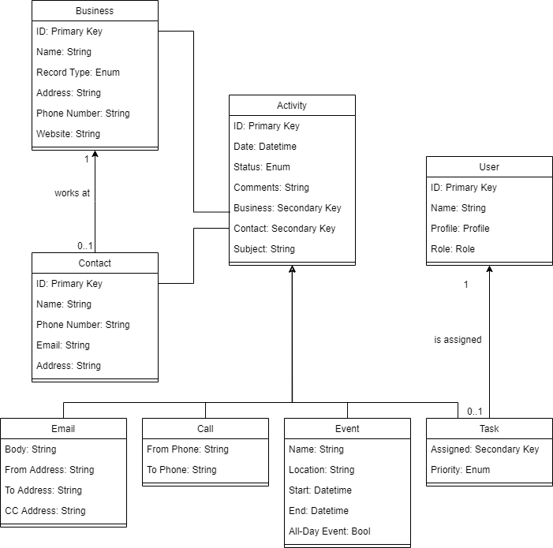
Figure 1: Activity Management

Flowchart – Order management
Order management is one of the processes that AVGC would like to have converted into their new unified system. The flowchart helps illustrate all the different steps in the order management process that need to be replicated in Salesforce.
When a customer requests a quote from AVGC, the quote would need to be created in Salesforce and sent to the customer. The user needs to be able to follow up with the customer until they sign the quote. Once the customer decides to order, the user would need to be able to convert the quote into an order in the system. That would trigger a parts list to get sent to the warehouse, to confirm inventory and fulfill the order.
*** Update image with all the same arrows
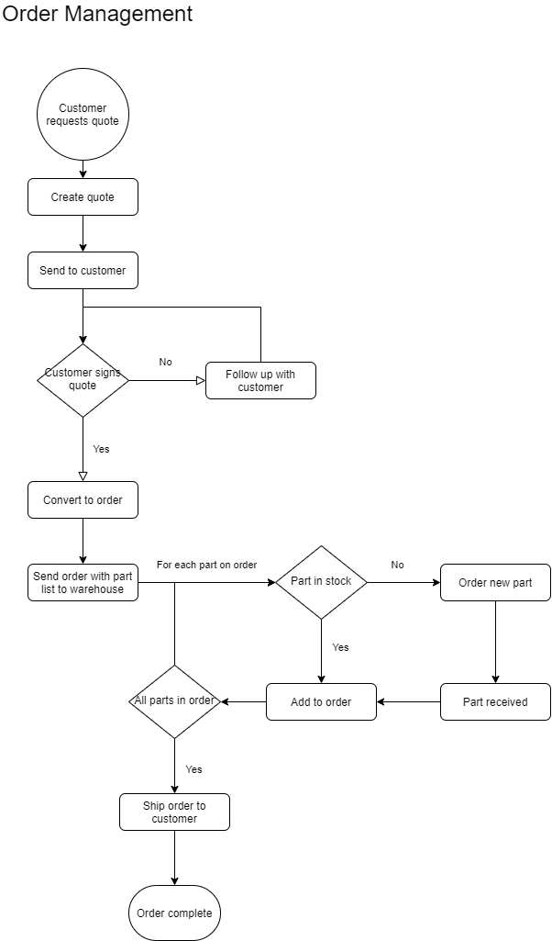
Figure 2: Order Management

Testing
Provide a brief introduction to the proposed testing solution. The tests need to be from 3 completely different functionality aspects. Testing the same aspect with slightly different criteria is not acceptable.
**Note: Add and remove subsections as needed to cover all the testing needs.
- Unit Testing – Handling duplications in contacts
- Functional Test – Take a customer all the way through the order process
- Performance Testing – Normal usage, heavy user load, time of day. How can I measure this?

Unit Testing
Provide a brief introduction paragraph.

Handling duplicate contacts

Requirement to be tested:

Preconditions: Conditions that must be present before test case can successfully run

Steps: The steps the tester must execute to test the feature.

Expected results: Expected results and any side effects such as updating a database, writing to a file, etc.

Pass/Fail: Mark whether the test case passed or failed. The results can be compiled and used to determine if the application is ready for delivery/release.

Test Name 2

Requirement to be tested

Preconditions: Conditions that must be present before test case can successfully run

Steps: The steps the tester must execute to test the feature.

Expected results: Expected results and any side effects such as updating a database, writing to a file, etc.

Pass/Fail: Mark whether the test case passed or failed. The results can be compiled and used to determine if the application is ready for delivery/release.

Test Name 3

Requirement to be tested

Preconditions: Conditions that must be present before test case can successfully run

Steps: The steps the tester must execute to test the feature.

Expected results: Expected results and any side effects such as updating a database, writing to a file, etc.

Pass/Fail: Mark whether the test case passed or failed. The results can be compiled and used to determine if the application is ready for delivery/release.

Sources
Place the sources that you used here.
https://www.salesforce.com/crm/what-is-crm/
https://www.salesforce.com/products/platform/best-practices/cloud-computing/?d=70130000000i88b
https://www.salesforce.com/privacy/overview/
https://www.thestreet.com/technology/what-is-salesforce-14796378
https://developer.salesforce.com/docs/atlas.en-us.securityImplGuide.meta/securityImplGuide/admin_userprofiles.htm
https://help.salesforce.com/s/articleView?id=000346575&type=3
https://www.salesforce.com/editions-pricing/sales-cloud/

